Star of the Sea Catholic College

Information Booklet for Parents

Corner Friend & William Streets
George Town 7253
P.O. Box 206, George Town 7253

Ph: 03 6382 1242

Email: sots.reception@catholic.tas.edu.au

www.starsea.tas.edu.au

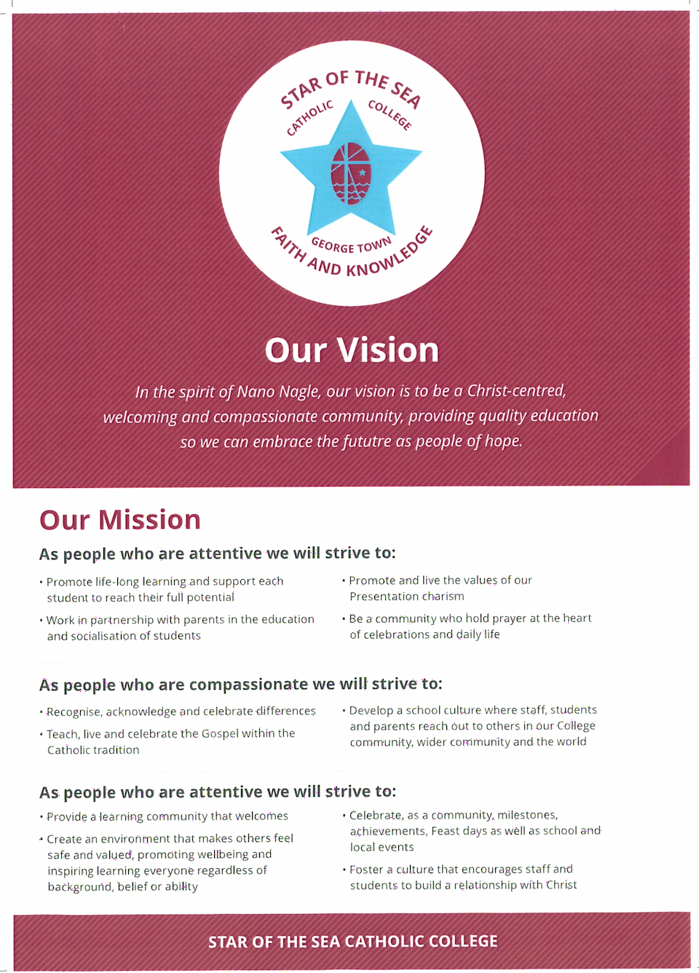

Welcome from the Principal

Welcome to Star of the Sea Catholic College
On behalf of the staff and students of Star of the Sea I welcome you to our school. Founded in 1957 by the Presentation Sisters, Star of the Sea has been serving the families of George Town and its surrounding communities for 60 years.
Star of the Sea Catholic College provides education to students from Kinder through to Year 10.
Star of the Sea prides itself on providing quality education in a safe and supportive environment. With small class sizes guarantee individual attention, the College has a strong history of giving students the skills they need to move onto Year 11 and 12 or work successfully. The College welcomes diversity and is supportive of students with learning needs, with a strong pastoral atmosphere.
We promote our SWPBS expectations of being Safe, Respectful, Engaged Learners. As part of the broader Catholic Education system in Tasmania, our teachers have access to ongoing professional development, whilst our students from Grades 5 through to 10 have ready access to devices in order to ready themselves for the technological world ahead of them.
I welcome prospective students and their families to contact me here at the College to find out more.

Mr Richard Chapman - Principal

Curriculum

Religious Education
The Good News for Living curriculum guides our school program. We provide a program that is faithful to the Gospel, and to the human person, by providing learning experiences and Liturgical Celebrations that are relevant to the child and develop the foundation for a Christian way of life.
Specific Sacramental preparation occurs at Parish level supported by the School.
- Sacrament of Reconciliation
- Sacrament of Eucharist
- Sacrament of Confirmation

Art
In Secondary art there may be occasions when students are asked to bring in something that can act as a smock in order not to damage their uniform.

Library
The Primary students use the library each week and each child is required to have a library bag for protecting library books when carrying them. Secondary students access the Library on a needs and interest basis.
It is important that books are returned on time.
Lost library books must be replaced, or the replacement cost paid.

Cooking
Secondary students who participate in Cooking courses must wear an apron and hat when engaged in cooking preparation. These items can be purchased through the Uniform Shop.

Inter-school Sport
The College is part of the Tamar Primary Schools Sports Association (TPSSA) and the Northern High Schools Sports Association (NHSSA). Through these associations the students are involved Swimming, Athletics and CrossCountry carnivals, as well as winter sports for Grades 5s and 6s and Years 7-10s. The school also participates in other sporting opportunities when they arise.

Technology
To keep costs at a minimum for families, Star of the Sea Catholic College provides devices for students.
Primary students have access to iPads, MacBooks and Chromebooks, while secondary students have access to Chromebooks and MacBooks.
There is also provision for secondary students to bring their own devices.

Reporting
Students are reported upon in accordance with Tasmanian Catholic Education reporting procedures. This sees an Interim Report approximately mid-way through Term 1, and fuller reports towards the end of Terms 2 and 4.
Uniform
Uniform Policy
It is the expectation of the school that all students from Prep to Year 10 wear the correct school uniform. This includes wearing Sports Uniform on P.E. days as per school timetable. Kindergarten students wear Sports Uniform throughout the year. Students in incorrect uniform should have a note. Summer uniform can be worn in Terms 1 and 4. Winter uniform is to be worn in Terms 2 and 3.

Uniform Shop
We have a Uniform Shop located in the Secondary Campus. We stock a wide selection of new and pre-loved uniforms.
Opening Hours are:-
Thursday 2.00pm -4.00pm

Uniform

Kinder Uniform

College Rugby Top
College polo shirt
College PE short
College track pant
College school bag
Library bag
College hat
White/black runners
White socks

GIRLS

Summer
College dress – Grey socks
Black school shoes
College jumper / College blazer
College hat (Primary only)

Winter
College skirt or College trousers
College jumper / College blazer
Mid-blue Midford school shirt - short or long sleeves
Grey socks or black tights worn with skirts or grey socks worn with trousers
Black school shoes

Physical Education (Prep to Year 10)
Maroon sports top - Black P.E shorts
White sports socks
Sports shoes appropriate to the uniform
Plain black track pants
Rugby Top
One piece bathers or singlet top (not crop) bathers for
swimming lessons and carnivals

BOYs
Summer
Grey melange trousers or grey school shorts
Mid-blue open-neck (short or long sleeve) Midford school shirt
Black school shoes
Grey socks
College jumper/College blazer
College hat (Primary only)

Winter
Grey melange trousers
Mid-blue Midford school shirt - short or long sleeve
College jumper / College blazer
Grey socks
Black school shoes

Physical Education (Prep. to Year 10)
Maroon sports top
P.E. shorts
White sports socks
Sports shoes appropriate to the uniform
Plain black track pants
Rugby Top

All clothes should be clearly marked with the child's name

Other items:
- College backpack with school logo (can be purchased at school).
- Library folder with school logo for reading books.
- When outside, plain black or maroon coats or jackets may be worn in addition to, but not in place of, the College jumper or blazer

Hairbands and Jewellery:
- Jewellery should be simple and kept to a minimum.
- For WHS reasons, all shoulder length hair must be tied or pulled up for some secondary subjects.
- Make up should not be noticeable. Parents will be contacted if it becomes an issue.
- Tattoos should not be visible.

Sun Awareness
We are a Sun Smart School. Each Primary child is required to wear our College hat in Terms 1 and 4. Students who do not wear a hat will be seated in the shaded areas during recess and lunch.

School Procedures

School Hours

Primary
Classes begin at 8:50am.

Children should not arrive at school before 8.30a.m. If it is necessary for your child to arrive prior to 8.30am they should wait outside the lower Primary classes. At 8.30am classrooms will be open and supervised by their classroom teachers, although there will always be one teacher on duty.

With the exception of bus children, all children should be collected at 3.00 p.m. For the children's safety, if parents are going to be late, the school should be notified. It is important that parents contact the College Office so that class teachers and children may be informed.

Secondary
The first bell sounds at 8:40am for students to move into Class Teacher time and get prepared for the day. The first class begins at 8:50am.

Primary and Secondary
Recess: 10:50 – 11:20am
Lunch: 12:40 – 1:20pm

Behaviour Management Structure
Behaviour Management is in line with School Wide Positive Behaviour Support.
The School has a clear behaviour management approach for the playgrounds, with parents kept informed of any high level negative behaviours.

Bus Supervision and Conduct
Children catching a bus home assemble at the canteen area ready to move through the gate to the bus stop when directed by the duty teacher. College staff collect Early Years children from their classrooms and accompany them to the bus stop. A teacher is on duty to supervise children until all buses have departed. The College and the bus companies expect a high standard of student behaviour on buses.

College Canteen
The College canteen is on the Secondary campus. All students are able to order their lunch from the canteen on any day. Secondary students are also able to purchase items from the canteen during recess and lunch. We would encourage parents to recognise that some products sold at the canteen are “sometimes” foods and that students should not be eating them every day.

Leaving School Grounds
No student is permitted to leave the school grounds during the day unless accompanied by a parent/carer and after permission has been granted by the Class Teacher or Principal. The Parent/Carer is to sign the student out at the Compass Kiosk in the School Office at the time of leaving.

Communication
Our Compass portal allows you to have access to information about our school, your child’s progress, communication with your child’s teacher and much more. Each parent will receive a separate login to Compass which will provided to you by our school on commencement of enrolment.

Primary students are issued with a communications book. This is used for communication from Class Teacher to Parent.

A School Newsletter is issued weekly to communicate the main school news items and includes a calendar of approaching events.

Facebook is also used to keep parents informed in a timely manner.

Assemblies
A Primary assembly is held each week, on Thursday at 2.10pm. Parents are very welcome to attend. Secondary assemblies are held every two weeks. At the close of each Term we hold a whole school Assembly and Award presentation at Our Lady Star of the Sea Catholic Church. We encourage parents, family members and visitors to attend.

Banking
Heritage Isle Credit Union Student Banking is provided. Each Friday students place their bankbooks and deposits in the class folder.

Personal Items
- All personal items and clothing should be clearly named.
- Valuable items should not be brought to school.
- No responsibility can be taken by the school for personal property.

Lost Property
Clearly labelled garments minimise the possibility of loss. Lost property is sent to the school office where it can be claimed. At the end of each year, unclaimed clothing is sold or donated to needy families.

Houses
For College carnivals and activities, students are placed into one of three Houses. Siblings will always be placed in the same House. The names of the three Houses reflect the history and charism of Star of the Sea Catholic College:

Presentation (Yellow) – named for the Presentation Sisters, the founders of Star of the Sea Catholic College.
Nagle (Green) – named for Nano Nagle, the founder of the Presentation Sisters.
Regina (Blue) – named for Mary, mother of Jesus, with Regina being the Latin word for Queen.

Bikes and Scooters

Students are able to ride bikes and scooters to school each day and we have bike racks situated on both campuses. However, due to workplace health and safety considerations, bikes, scooters and skateboards should not be ridden on the school property.

Nut Free
Due to allergies by a number of students, the Star of the Sea Catholic College canteen does not sell products containing nuts. We would also ask parents to ensure that no nuts or nut-based products are packed in student lunch boxes.
Counselling
The College has counselling services operated by CatholicCare who provide a counsellor at the school, currently two days per week.

Mobile Phones
Mobile phones are not to be seen or used by students during school time.

Parent Information

Notification of Absence of Child
The school should be contacted by the child's parent on the morning of the child's absence. This can be done by phone, through your Compass App or Facebook messaging.
Where it is known in advance that a child will be absent, the school should be informed by the parent in advance, preferably in writing.

School Board of Management
The School Board is an advisory board made up of members of the School Community and the Principal. The Board’s main function is to advise and support the Principal in the financial and operational management of the school.

Parents and Friends
Parents and Friends meet approximately once a month during the school year. The aim of the Parents and Friends is to build community between staff, students and parents, as well as raising funds for College resources. Meeting times and places are advertised in the College newsletter.

Entering School Grounds
All persons visiting the school are required to report to the school office to register and receive a visitor's pass. Staff and students are trained to look for this identification in the interests of safety and courtesy. Volunteers at the College are all required to have Working with Vulnerable People cards.

School Crossing
Parents are asked to use the crossing to reinforce the correct crossing behaviour with their children.

Student Record/Medical Form
It is essential that all information on the Student Record/Medical Form is kept up to date. The school must be notified immediately if there are any changes to the details contained in the form.

A copy of a child's Birth Certificate should be provided to the school at the time of enrolment. If a child is baptised a copy of the Baptismal Certificate should be provided to the school at the time of enrolment. The school is also required by law to maintain an immunisation declaration statement, signed by a parent. When immunisations are updated a medical certificate should be forwarded to the school.

Medication
If children are required to take medication it is preferred that the parent administer the medication. If this is not possible, a letter clearly detailing the medication, dosage and procedure must be provided to the School Office in advance.
Any changes to established medication must also be clearly documented in a letter to the School Office. Medication must be given to the School Office and not left in the child’s school bag (unless it is an Asthma Puffer)
College Fees
Fee Structure

Fees
As Catholic schools are not funded by governments to the same extent as Government schools, fees help to make up some of the difference so that students across Tasmania can be offered choice.
In 2020, the following applies to individual students:

Kinder - $880
Primary - $1767
Secondary - $2346

Family Discounts
Star of the Sea Catholic College offers generous family discounts. Enquiries can be made to the College Bursar.

Financial
Families experiencing difficulties in meeting fee payments are asked to contact the Bursar or Principal to discuss payment arrangements. Where possible the school will offer financial assistance in respect to fees for those families experiencing genuine financial hardship. Star of the Sea Catholic College is a welcoming school so aims to not let financial hardship prevent students from receiving a Catholic education.

What if I can’t afford to pay full fees?
As many of our families know, Star of the Sea Catholic College understands that not all families can afford to pay full fees, but they still would like their children to attend our school. Therefore, we offer some choices as to how you can contribute.

- I have a Health Care Card
Catholic Education Tasmania has now introduced the policy of the maximum amount parents and carers on a Health Care card will be charged. At Star of the Sea the maximum amount charged for Primary students is $750 and for Secondary students is $1000 plus any levies that are payable. Normal family discounts apply.
Please note that this applies to parents or carers who have one of the following Health Care Cards:
- Commonwealth Seniors Health Care Card
- Ex-Carer Allowance (Child) Health Care Card
- Health Care Card
- Low Income Health Care Card
Families who have one of these Health Care Cards but wish to receive a further discount, or do not have one of these
cards can apply for fee assistance (see below).

- I would like Fee Assistance
Families who would like Fee Assistance are required to fill out the appropriate forms from the school. These forms give an indication as to family income. The family and the school then come to an agreement as to how much will be paid for the year. Assuming this amount is paid, the rest of the fees are wiped.

- I would like Fee Assistance but would prefer to deal with it outside of the school
Families who wish to apply for Fee Assistance but would prefer to do so without school involvement only need to contact Mrs Kathryn Condric and we will organise for an outside agency to work with you for Fee Assistance. When this happens, the school is not informed of a family income but only informed of how much the family will pay for the year. As with above, assuming that amount is paid the rest of the fees are wiped.

